**Experiment 1**:- Starting of DC Motor

**Software used**:- Matlab

**Theory:-**

A 3 point starter in simple words is a device that helps in the starting and running of a shunt wound DC motor or compound wound DC motor. Now the question is why these types of DC motors require the assistance of the starter in the first case. The only explanation to that is given by the presence of back emf Eb, which plays a critical role in governing the operation of the motor. The back emf, develops as the motor armature starts to rotate in presence of the magnetic field, by generating action and counters the supply voltage. This also essentially means that the back emf at the starting is zero, and develops gradually as the motor gathers speed.

**Circuit:-**

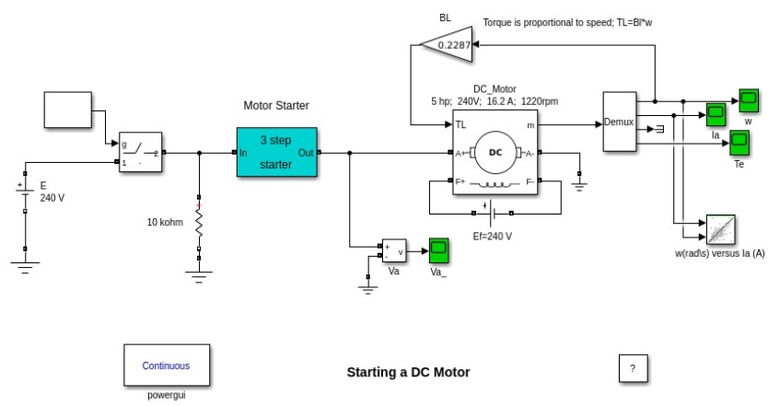

**Graph:-**

Time

RPM

Time

Torque

Time

Current

**Experiment 2:- SPEED CONTROL OF DC MOTOR**

**Software used**:- Matlab

**Theory:-**

Controlling a DC motor's speed is achieved simply by controlling the voltage of the supply power (within the safe operating range for the motor) using a potentiometer. DC motors maintain consistent torque across the entire speed range without the need for additional components. This makes controlling their speed considerably easier than AC motors, and they are well suited to applications requiring precise control at any speed.

However, further considerations are depending on the requirements of the speed controller. DC controllers operating on AC power require conversion of the supply using a rectifier. Unlike AC motors, braking or reversing a DC motor requires additional components, typically a power resistor for braking and a relay for switching the polarity of the supply power to reverse the motor. It is also necessary to ensure that the motor has stopped before reversing the polarity of the supply, which requires a means of sensing when the motor is at a standstill. This can add up to a significant additional cost, especially for larger applications.

**Circuit:-**

**Graph:-**

**Experiment 3:- Induction Generator**

**Software used:-**  Matlab

**Theory:-**

Electromagnetic induction is the key factor in a generator’s operation. The main parts of the generator are carbon brushes, slip-rings, rotor and stator. The rotor is an electromagnet made by coiling wires around two or more poles of metal core. The stator is a pair of plates attached to the axle. The brushes are connected to the source of energy and work with commutator in order to let the induced current flow around the system. Once the shaft and coil start spinning around the shaft, there is some current and electromotive force produced. This induced current moves in the opposite direction of the rotation.

**Circuit diagram:-**

**Graph:-**

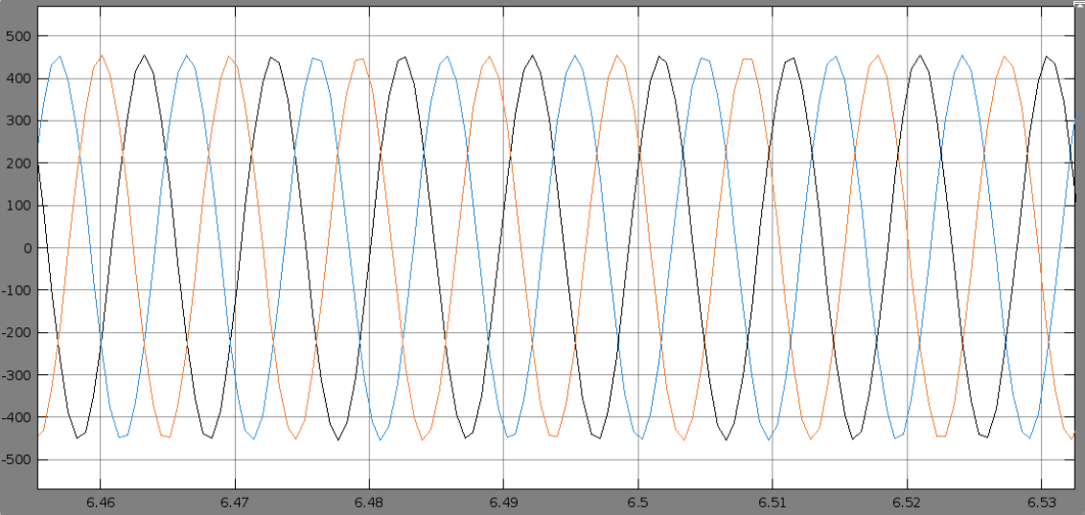

**Experiment 4:- Single Phase Induction motor using motor drive**

**Software:-** Matlab

**Theory:-** Induction motors are commonly used in industries as they are economical, rugged, and reliable and are available in a range of fractional horse power to multi-megawatt capacity. Squirrel-cage and Wound rotor are the two configurations in three phase machines. In a wound rotor machine, the rotor winding is similar to that of stator, whereas in a cage machine, the rotor has a squirrel cage like structure with shorted end rings.

**Circuit diagram:-**

**Graph:-**

**Experiment 5:- Starting of Synchronous Motor**

**Software:-** Matlab

**Theory:-**

The synchronous machine block shown in operates in generator or motor modes. The operating mode is dictated by the sign of the mechanical power (positive for generator mode, negative for motor mode). The electrical part of the machine is represented by a sixth-order state-space model and the mechanical part is the same as in the Simplified Synchronous Machine block. The model takes into account the dynamics of the stator, field, and damper windings. The equivalent circuit of the model is represented in the rotor reference frame (qd frame). All rotor parameters and electrical quantities are viewed from the stator. They are identified by primed variables.

The machines initially operate in steady state at virtually no load (load = 0.1% of nominal power) with constant field voltage and mechanical power. The Scope shows the comparison between line-to-line AB voltage, phase A stator current, and field current of the machine.

**Circuit diagram:-**

**Graph:-**

